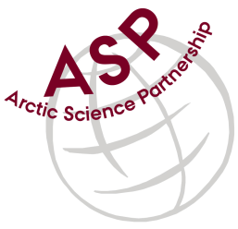

Minutes from ASP Laboratory Team Meeting

Date: March 14th, 2024
Present: Marcos Lemes (UM), Egon Frandsen (AU), Else Ostermann (GNI), and Katharina Hamer (GNI), Ilka Peeken (AWI), Christien Laber (UiT), Ilka and Marie-Hélène (UL)

Absent: Karley Campbell (UiT),

Referee: Marcos

This is meeting has been taken online.

We have discussed below topics:

- Marcos (UM) updated members from Lab Team about the ASP General Meeting (Feb 28th and 29th) and showed a presentation shown at General Meeting to whom was at the meeting.
- As suggestion of ASP general meeting members, we are going to begin comprehensive DIC exercise.
- We started to discuss how we could get a larger number of participants to this exercise. Egon (AU) suggested to invite two or three labs from Denmark
- Ilka (AWI) will see whether a lab from her institute would like to participate as well.
- Marcos of (UM) will see if University of Alberta or DFO are willing to participate in this exercise.
- Egon (AU) and Marcos (UM) talked about the DIC results from the samples and compared discrepancies on respective instrument’s manuals (e.g.: H₃PO₄ concentration)
- The group also started to brainstorm the possibility to find another type of preservative to the TA/ DIC samples other than HgCl₂

Please use Teams link https://teams.microsoft.com/l/meetup-join/19%3aiaBWS_EnwxKky61JDxNP89AT3vq9AlgyUTHa4FP4Xpc1%40thread.tacv2/1681337140562?context=%7b%22Tid%22%3a%224f80dd0b-338c-4e4c-8a14-90446962f7b8%22%2c%22Oid%22%3a%2271262080-0ca9-4c08-ba54-444a9d0cbce3%22%7d for the meetings

All members agreed regarding the meeting dates; all online meetings will be on second week of each month on Wednesdays at 15h00 Central European Time (CET).

IMPORTANT NOTE: Next team meeting will be on April 11st 2024 at 15h00 CET

