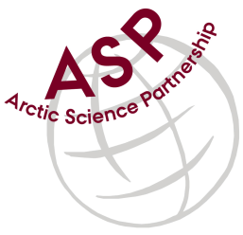

Minutes from ASP Laboratory Team Meeting

Date: February 8th, 2023
Present: Marcos Lemes (UM), Marie-Hélène (UL), and Ilka Peeken (AWI),
Absent: Karley Campbell (UT), Egon Frandsen (AU), and Else Ostermann (GNI)
Referee: Marcos

This is meeting has been taken online.

We have discussed below topics:

- We continued to discuss on the chlorophyll report draft. Some new inputs and information were provided by the members.
- This chlorophyll report will be presented during General Meeting in Nice (February 17th and 18th, 2023).

Please use Skype link https://join.skype.com/uKv5ArcoaxDw for the meetings

All members agreed regarding the meeting dates; all online meetings will be on second week of each month on Wednesdays at 15h00 Central European Time (CET).

IMPORTANT NOTE: Next team meeting will be on March 15th 2023 at 15h00 CET

