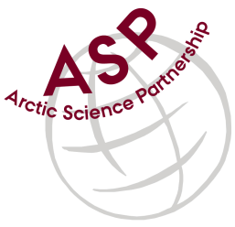

Minutes from ASP Laboratory Team Meeting

Date: February 9th, 2022
Present: Marcos Lemes (UM)
Absent: Egon Frandsen (AU), Else Ostermann (GNI), Anette Rasmusssen (AU), Karley Campbell (UT), and Marie-Hélène (UL)

Referee: Marcos

This is meeting has been taken online.

Majority of the team was unable to join the meeting for vary reasons.

Marcos (UM) has sent an email to the team sharing updates:

- We received funding to purchase the dry shipper;
- CTD calibration from Søren - Aarhus has one system developed and is willing share the know-how with us (Canada) to have same system.
- Perhaps you have fund to help Karley with shipping chlorophyll samples to us.

Please use Skype link https://join.skype.com/uKv5ArcoaxDw for the meetings

All members agreed regarding the meeting dates; all online meetings will be on second week of each month on Wednesdays at 15h00 Central European Time (CET).

Next meeting: Next team meeting will be on March 9th 2022 at 15h00 CET

