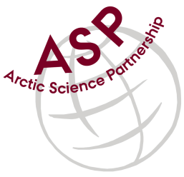

Minutes from ASP Laboratory Team Meeting

Date: May 12nd, 2021
Present: Anette Rasmusssen (AU), Karley Campbell (UT), and Marcos Lemes (UM)
Absent: Else Ostermann (GNI), Emil Munk (GNI), and Marie-Hélène (UL), and Egon Frandsen (AU)
Referee: Marcos

Thank you all for joining the ASP Lab Team meeting. This is meeting has been taken online.

Members discussed further how collaborate among the network.

In this meeting we started to discuss the technique (chlorophyll) that most labs have in common. We have confirmed that different laboratory uses different methodology. For instance, ethanol and acetone are used for sample extraction. Most of the time was spent discussing details of the technique.

We have decided to wait for other labs to present their methodology for chlorophyll as well.

Please use Skype link https://join.skype.com/uKv5ArcoaxDw for the meetings

Meeting for 2021 will follow these dates at 15h00 CET:
June 9
July 14
August 11
September 8
October 13
November 10
December 8

