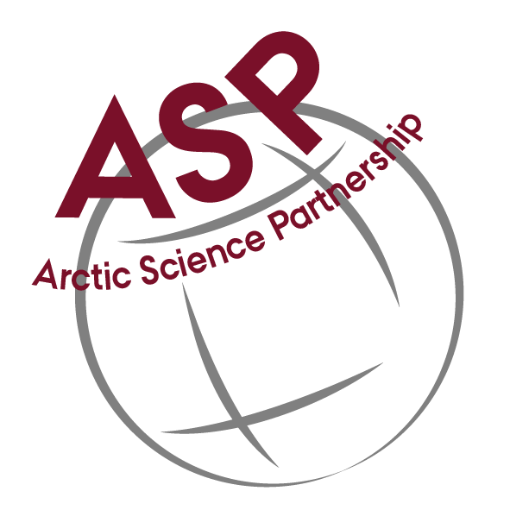
Arctic Science Partnership (ASP)
annual meeting

28-29 February 2024
Bernstoff Carstle, Jærgersborg Allé 93
2820 Gentofte
https://bernstorffslot.dk/kontakt/

Agenda

This 2024 annual ASP meeting aim to update its work roadmap and discuss ideas for the coming years with focus on: Now2New & Baffin Bay

Wednesday 28 February  08.00-09.00 | Breakfast
09.00 – 09.30 | Welcome and short round table presentation of participants (Dorthe)
09.30-10.30 | Short (5 min) overall presentation of recent non ASP activities in 2023 from each institution. Make sure to prepare this before the meeting.  - uManitiba  - uLaval  - DFO  - GINR  - UiT  - AWI  - KU  - AU
10.30 -11:00 | Coffee
10.30-12.00 | Follow-up on Now2New ASP initiative (what have happened since Nice 2023)  - Ice drilling (Müller & Tausen)  - Trans Polar drift (Tara, St Nord, Alert, Pearl, Svalbard)  - Atmosphere, sea ice - ocean interactions (Baffin Bay, NE Greenland)
12.00-13.00 | Lunch
13.00-15.00  Breakout  groups | Linking atmosphere, ice and ocean (understanding high-arctic climate change- heat, energy, freshwater) - Identifying missing knowledge  - Ice drilling (Müller & Tausen)  - Trans Polar drift (Tara, St Nord, Alert, Pearl, Svalbard)  - Atmosphere, sea ice - ocean interactions (Baffin Bay, NE Greenland)  - Support staff (admin, operation, laboratory, communication)
15.00-15.30 | Coffee
15.30-17.30  Plenum | Report from breakout sessions  - Ice drilling (Müller & Tausen)  - Trans Polar drift (Tara, St Nord, Alert, Pearl, Svalbard)  - Atmosphere, sea ice - ocean interactions (Baffin Bay, NE Greenland)  - Support staff
17.00-18.00 | Drink and talk
18.00-20.00  Plenum | Dinner
20.00-21.00 | Evening talk (invited guest)

Thursday 29 February  08.00 - 09.00 | Breakfast
09.00 - 10.30 | Identifying possibilities for:  - Logistic collaboration  - Joint proposals  - A high impact joint publication  - other
10.30 -11.00 | Coffee
11.00-12.00 | Consolidating of ASP research plan  - Who does what and when?
12.00-13.00 | Lunch
 | End of meeting

