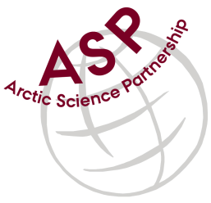

Minutes from ASP Laboratory Team Meeting

Date: October 12nd, 2023
Present: Marcos Lemes (UM), Ilka Peeken (AWI), and Christien Laber (UiT)
Absent: Egon Frandsen (AU), Karley Campbell (UiT), Else Ostermann (GNI), Katharina Hamer (GNI), and Marie-Hélène (UL)
Referee: Marcos

This is meeting has been taken online.

We have discussed below topics:

- We started to discuss options for interlaboratory comparisons. Analyses discussed such as TA, DIC, nutrients, POC and PON.
- Marcos will send an email to the group for choosing the next interlaboratory comparison. Marcos can provide low and high salinity samples for TA and DIC, if they are chosen ones.
- Ilka will be absent until next year. She goes to fieldwork in Antarctica.

Please use Teams link https://teams.microsoft.com/l/meetup-join/19%3aiaBWS_EnwxKky61JDxNP89AT3vq9AlgyUTHa4FP4Xpc1%40thread.tacv2/1681337140562?context=%7b%22Tid%22%3a%224f80dd0b-338c-4e4c-8a14-90446962f7b8%22%2c%22Oid%22%3a%2271262080-0ca9-4c08-ba54-444a9d0cbce3%22%7d for the meetings

All members agreed regarding the meeting dates; all online meetings will be on second week of each month on Wednesdays at 15h00 Central European Time (CET).

IMPORTANT NOTE: Next team meeting will be on November 9th 2023 at 15h00 CET

