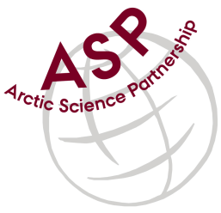

Minutes from ASP Laboratory Team Meeting

Date: October 12^{n}, 2022
Present: Marcos Lemes (UM), Marie-Hélène (UL), Egon Frandsen (AU), and Karley Campbell (UT) (auditing the meeting)
Absent: Else Ostermann (GNI),
Referee: Marcos

This is meeting has been taken online.

We have discussed below topics:

- Some members had done the chlorophyl analysis other ones still to do by the end of the week.
- A discussion started on data presented in this meeting.
- All members sent chlorophyll data and Karley’s checklist table by October 14th

Please use Skype link https://join.skype.com/uKv5ArcoaxDw for the meetings

All members agreed regarding the meeting dates; all online meetings will be on second week of each month on Wednesdays at 15h00 Central European Time (CET).

IMPORTANT NOTE: Exceptionally the next team meeting will be on November 9th 2022 at 15h00 CET

