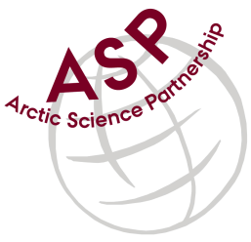

Minutes from ASP Laboratory Team Meeting

Date: October 13rd, 2021
Present: Anette Rasmusssen (AU), and Marcos Lemes (UM), Karley Campbell (UT) -joined by phone
Absent: Emil Munk (GNI), and, and Egon Frandsen (AU), Else Ostermann (GNI), Marie-Hélène (UL)

Referee: Marcos

Thank you all for joining the ASP Lab Team meeting. This is meeting has been taken online, resuming from a summer break

Members discussed further how collaborate among the network.

In this meeting we continued to discuss the technique chlorophyll which most labs have this analysis in common. We have confirmed that different laboratory uses different methodology.

Karley Campbell had volunteered herself to collect chlorophyll samples and ship them for an intercomparison among the labs. She and her team will collect on October 15th, 2021 nearby Norwegian fjords.

Since few people were attending this meeting, Anette and Marcos discussed ARC’s new DIC system.

Please use Skype link https://join.skype.com/uKv5ArcoaxDw for the meetings

Meeting for 2021 will follow these dates at 15h00 CET:
June 9
July 14
August 11
September 8
October 13
November 10
December 8

