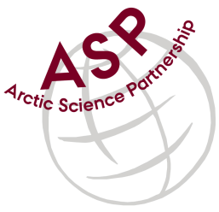

Minutes from ASP Administration Meeting

Date: September 4, 2019
Present: Else Løvstrøm, Egon Frandsen, Peter Bondo Christensen and Peter Schmidt Mikkelsen
Referee: Peter

- Introduction
Short introduction of Else, who is participating for the first time. Collaboration is working well between the ASP partners.
- Participants
Else informed that the new Natur.gl website will soon be up and running. The current one is old and not mobile friendly.
No representatives from CEOS attended the meeting.
- Dates
The Annual ASP meeting will take place on Saga Hotel in Reykjavik on 8-9 October 2019..
- Next meeting
Next team video-meeting will take place on 6 November 2019 at 15.00 CET.

